

PuzzPak

Detailed Design Document



D a n i e l l e M a r c o u l l i e r
M a r c h 2 3 , 2 0 1 6
T A B L E O F C O N T E N T S

Executive Summary. . . . . . . . . . . . . . . . . . . . . . . . . . . . . . . . . . . . . . . . . . . . . . . . . . . . . . . . . . . . . . . 3
Systems Request . . . . . . . . . . . . . . . . . . . . . . . . . . . . . . . . . . . . . . . . . . . . . . . . . . . . . . . . . . . . . . . . . 4
Analysis & Findings: Structured English. . . . . . . . . . . . . . . . . . . . . . . . . . . . . . . . . . . . . . . . . . . . . . .5
Context Diagram. . . . . . . . . . . . . . . . . . . . . . . . . . . . . . . . . . . . . . . . . . . . . . . . . . . . . . . . . . . . . . . .7
Data Flow Diagram. . . . . . . . . . . . . . . . . . . . . . . . . . . . . . . . . . . . . . . . . . . . . . . . . . . . . . . . . . . . . .7
Decision Tree. . . . . . . . . . . . . . . . . . . . . . . . . . . . . . . . . . . . . . . . . . . . . . . . . . . . . . . . . . . . . . . . . . 8
Recommendations. . . . . . . . . . . . . . . . . . . . . . . . . . . . . . . . . . . . . . . . . . . . . . . . . . . . . . . . . . . . . . . . 9
Data Dictionary. . . . . . . . . . . . . . . . . . . . . . . . . . . . . . . . . . . . . . . . . . . . . . . . . . . . . . . . . . . . . . . .10
ER Diagram:. . . . . . . . . . . . . . . . . . . . . . . . . . . . . . . . . . . . . . . . . . . . . . . . . . . . . . . . . . . . . . . . . .11
Input-Output Design. . . . . . . . . . . . . . . . . . . . . . . . . . . . . . . . . . . . . . . . . . . . . . . . . . . . . . . . . . . . . .12
Physical Design. . . . . . . . . . . . . . . . . . . . . . . . . . . . . . . . . . . . . . . . . . . . . . . . . . . . . . . . . . . . . . . . . 14
The Plan. . . . . . . . . . . . . . . . . . . . . . . . . . . . . . . . . . . . . . . . . . . . . . . . . . . . . . . . . . . . . . . . . . . . . . . 15

E X E C U T I V E S U M M A R Y

Upon analyzing the gaming community as a long time member, gaming seems to be more fun when other people are involved in the same games. A lot of games are played over the Internet with other people with no face-to-face contact with them, but all people involved in the community still enjoy these games.
As time progresses, games become more complex and require higher hardware qualifications in order to play them. There are some people in the community who would like to play an easy-to-understand but equally challenging video game without the need for special software and hardware, but still be able to interact with a community in a way.
Based on these observations, the idea for a program with some well-known games packaged into it comes to mind. Players who download this package don't need to download any special software other than the Java Runtime Environment (JRE), which is a common software people have on their personal computers already. They can interact with other people in the community by competing in the high scores, as well as trying to beat their own personal best. The games are easy to play, but each offer unique challenges.
Implementing this System would require the users to download it and run it, with the only installation requirement being a Java Runtime Environment. In addition, it no training/tutorial is necessary, as the games are well-known already, and it would need little to no maintenance.
S YS T E M S R E Q U E S T

There is a small demand for low learning curve videogames. Mobile gaming has become a huge platform with all ages who are looking for something they can just pick up and stay busy and entertained. While this system is not mobile, it does met up with the latter two attributes: Having a low learning curve, and offers a challenge to people.
While there are other programs that fill these needs, the addition of a game pack would provide gamers with more options. This program being a package with database capabilities built in may set it apart from other low learning curve games, which sit independently of any such system. Some gamers might find value in those extra capabilities.

A N A L Y S I S & F I N D I N G S :
S T R U C T U R E D E N G L I S H
- User Sign-In
  - If user doesn't exist, create new profile in player table. Continue as user.
  - If user exists, continue as user and save to this profile.
- Play Hangman
  - pick difficulty and start game.
  - Based on difficulty index, generate random number and select word at that index in word array. Set as secret word.
  - User guesses a letter:
    - Its existence is checked in the secret word.
    - If exists, all indeces of that letter are returned, to help display the board.
  - If user guesses entire word correctly, they get winning tally mark.
  - If user uses 6 wrong tries, they get a loosing tally mark.
  - If user plays 3 games and wins at least one.
    - If user posts:
      - Calculate user's score as a percentile of games won.
      - Save user's score to the HangmanAllTime Table in the database.
      - If this score is higher than the player's best score, update their profile.
    - If user doesn't post:
      - Toss the score.
- Play Tik-Tak (Tic-Tac-Toe Game)
  - Player plays an X.
    - check win, check tie.
  - Computer rolls the dice to randomly play an O in an open space.
    - check win, check tie.
  - Player plays their X.
    - check win, check tie.
  - Computer decides if they will lose next turn.
    - if yes, block.
    - If no, roll the dice until it gives a space that's open.
  - Player Plays their X.
    - Check win, check tie.
    - Computer decides if it will lose next turn, and blocks it.
    - Computer decides if it will win, and plays the winning chip.
  - If user plays 3 games (Tie/win/loss) and wins at least one:
    - If user posts:
      - Calculate user's score as a percentile of games won.
      - Save user's score to TikTakAllTime Table in the database.
      - If this score is higher than the player's best score, update their profile.
    - If user doesn't post:
      - Toss the score.
- Play Memory Tiles (4x4 and 6x6)
  - Randomize the board, placing 2 of each shape about the board.
  - Show the whole board for 800ms on small game, 1200ms on hard. Then hide them.
  - User picks 2 tiles.
    - If they match, keep them visible, but disabled. Give user 5 points.
    - if they don't match, take 2 points from user.
  - If all tiles are visible and disabled, the game is over
    - if the score is greater than 0, they won.
      - Allow user to post score by enabling the button.
        - Save score to all-time table, and if the score is greater than their previous score, update their profile to the new score.
        - If the user doesn't post and starts a new game, disable the button and toss the score.
    - if the game is a 0 or lower they lost.
      - User is not allowed to post this score.
C O N T E X T D I A G R A M

D A T A F L O W D I A G R A M
D E C I S I O N T R E E
R E C O M M E N D A T I O N S
In order for the game pack to be a success, all users who wish to take part in using this program is required to have a personal computer or access to a personal computer.
The computer is recommended to have at least 512MB of RAM, 32 bit color, and a dual core processor. These requirements are in place because the computer that runs an operating system with a GUI, as well as the game pack would use up these resources. Having greater hardware specifications would be ideal, but this amount is the minimum of what a computer should have to participate.
An Internet connection is also suggested, because it allows the user to get the full experience of the game pack. The purpose of this program is to allow users to play low-end, challenging games in a social way. Players will be able to have access to the leaderboards database to see what their friends have scored, as well as making it easy to compete against themselves to try and beat your own personal best. Posting a score is remarkably easy, because all players have to do is hit the post button. The program will decide if the score is a new high score, and keep track of all records automatically. While an Internet connection it is not required, it is favorable.
If all of these recommendations are met by players, they will have an optimal experience because they can not only play the games, they can participate in everything the game pack has to offer.

D A T A D I C T I O N A R Y

PuzzPak Data Dictionary
PK/FK | Field Name | Data Type | Field Size | Table(s)
PK | USERNAME | varchar(15) | 15 | Hangmanalltime, tiktakalltime, mt4x4alltime, mt6x6alltime
 | SCORE | decimal | 5 | Hangmanalltime, tiktakalltime, mt4x4alltime, mt6x6alltime
 | DATE | date | 10 | Hangmanalltime, tiktakalltime, mt4x4alltime, mt6x6alltime
 | GAME | varchar(7) | 7 | Hangmanalltime, tiktakalltime, mt4x4alltime, mt6x6alltime
PK | USERNAME | varchar(15) | 15 | player
 | HANGMAN | decimal | 5 | player
 | TIKTAK | decimal | 5 | player
 | MT4X4 | decimal | 5 | player
 | MT6X6 | decimal | 5

E R D I A G R A M
I N P U T – O U T P U T D E S I G N
A: Input: Creating an account or Logging in:
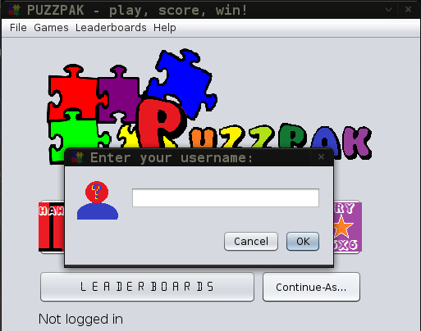
B: Input: Posting A score
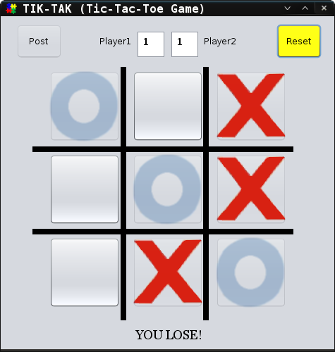

Posting a score is automatic once a user logs in. The username is a Global Variable within the application so every form has access to it. That username, the score from the game, the date from the operating system, and the game name are used to create a SQL query to add a new record to the database. It is more-or-less automatic for the user, and the same for all 4 games.
C: Output: Viewing player scores
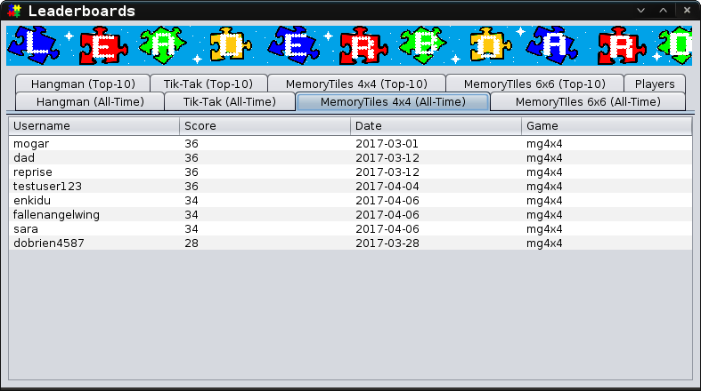
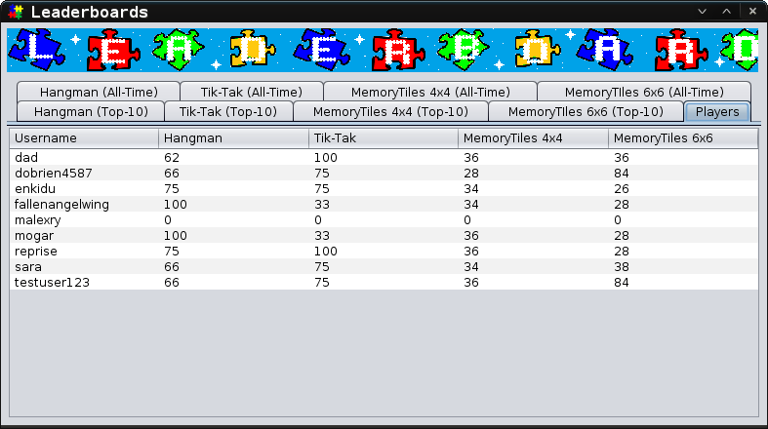
D: Output: Viewing user's accounts and their standing
P H Y S I C A L D E S I G N

In order to successfully implement the game pack to its target audience, each user within that audience must have a personal computer. There are 2 software requirements that must be met in order for the game pack to run properly. Their computer can run any operating system that supports a graphical user interface and is compatible with Oracle Java Runtime Environment 7 or higher.
The computer must also meet some physical requirements as well. It must have at least 512mb of RAM, a dual core processor, a mouse, keyboard, and monitor. An Internet connection is optional, because using the database is the user's choice. It simply offers a way to play games socially. They can still play the games without having an account, or participating in the high scores leaderboard.
T H E P L A N

Since everyday users are going to be using the system, they are responsible for downloading the package and using it on their own personal computers. The package will be distributed to the public through GitHub, Arch User Repositories (AUR) or Personal Package Archive (PPA). The public can use the GitHub website to download the package in the original format it was developed in, which is compatible with all platforms. For Linux users, they can download this package if their package manager is instructed to access the AUR or the PPA the package resides in. The package would be downloaded in the .deb or .tar format from these repositories. In all locations this package is accessed, the libraries needed for accessing the database are included.
Instructions for downloading, installing, and using the system is outlined in the user guide which is available to users when they get the software. While users are responsible for putting the system on their own personal computers, they do not need to handle the database in any way. The software is capable of connecting to a database by itself without user involvement. The database itself exists on a server, which allows for users all over the planet to use the leaderboard service.

